**Chromogenic Shgia toxin-producing *Escherichia coli* (STEC) medium**

|  |  |  |
| --- | --- | --- |
| **Product No.** | **Product Category** | **Specification** |
| CRM021C | Dehydrated Culture Medium | 500g/bottle |

**Intended Use**

For the isolation of Shiga toxin-producing *Escherichia coli* (STEC).

**Principle and Interpretation**

Peptone and yeast extract provide nitrogen, carbon sources, long-chain amino acids, vitamins, and essential nutrients.Chromogenic mixture reacts with STEC, producing purple-red to violet colonies.STEC O157:H7: Purple colonies, no fluorescence.Non-O157 STEC serotypes: Purple colonies with fluorescence (rare strains may lack fluorescence).Other Enterobacteriaceae: Colorless or blue colonies, or inhibited.Selective additives suppress Gram-positive bacteria and other contaminants.

**Formulation**

|  |  |
| --- | --- |
| **Ingredients** | **/liter** |
| Beef peptone + yeast extract | 8.0 g |
| Salts | 5.2 g |
| Chromogenic agent | 2.6 g |
| Agar | 15.0 g |
| pH 6.9±0.2 at 25°C | |

**Preparation**

Weigh 30.8 g of the medium base and dissolve in 1 L of distilled or deionized water.Stir and heat to boiling until fully dissolved.Cool to 50°C, then add 1 tube of supplementary reagent (SR0820) per 100 mL medium. Mix thoroughly.Pour into sterile Petri dishes and allow to solidify.

**Performance Characteristics**

STEC O157:H7: Pale purple colonies, no fluorescence.

Non-O157 STEC: Pale purple colonies with fluorescence.

Non-STEC E. coli: No growth or weak growth (rare strains may show purple colonies).

Other Enterobacteriaceae: Blue colonies.

Confirmation: Colonies must be further tested via serological or molecular methods.

**Quality Control**

Cultural characteristics observed after incubation at 35-37°C for 24 hours

|  |  |  |  |
| --- | --- | --- | --- |
| **Quality control strains** | **Approx. Inoculum(CFU)** | **Recovery** | **Characteristics** |
| *Escherichia coli*  CMCC(B)44939 | 10-100 | PR≥0.7 | Pale purple colonies, no fluorescence |
| *Citrobacter freundii* CMCC(B)43228 | 10-100 | PR≥0.7 | Pale purple colonies, fluorescence |
| *Salmonella typhimurium* ATCC 25922 | > 104 | G≤1 | No growth |
| *Enterococcus faecalis* ATCC29212 | > 104 | G≤1 | No growth |

**Storage and Shelf Life**

2-30℃，Keep container tightly closed, avoid direct sunlight.

Use before expiry date on the label.

**Precautions**

1. When weighing the dehydrated medium, please wear masks to avoid causing respiratory system discomfort

2. Keep container tightly closed after using to prevent clumping.

**Waste Disposal**

Microbiological contamination was disposed by autoclaving at 121°C for 30 minutes.

**Revision**

On June 14, 2024

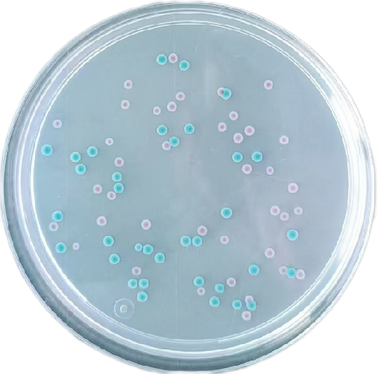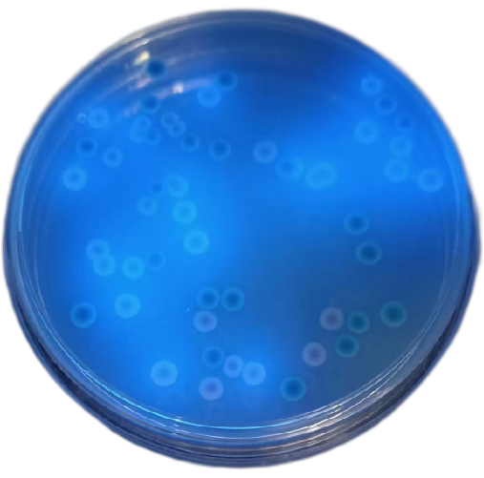

**Shiga toxin-producing *Escherichia coli* (STEC)**: Pale purple colonies, **no fluorescence**

**Non-STEC *Escherichia coli***: Pale purple colonies, **fluorescent**

**Other Enterobacteriaceae**: Colorless/blue colonies or inhibited/no growth