**Chromogenic *Yersinia Enterocolitica* Agar**

|  |  |  |
| --- | --- | --- |
| **Product No.** | **Product Category** | **Specification** |
| CRM017C | Dehydrated Culture Medium | 500g/bottle |

**Intended Use**

For the detection and differentiation of pathogenic *Yersinia enterocolitica*.

**Principle and Interpretation**

Peptone provides nitrogen sources, vitamins, and growth factors.Salts maintain osmotic balance; agar acts as the solidifying agent.Inhibitors (supplementary reagents) suppress contaminating flora.Chromogenic substrates react specifically with enzymes produced by pathogenic *Yersinia enterocolitica*, hydrolyzing the substrate to release chromogens. Pathogenic strains form lavender colonies, while non-pathogenic strains appear metallic blue or are inhibited.

**Formulation**

|  |  |
| --- | --- |
| **Ingredients** | **/liter** |
| Peptone | 9.0g |
| Salts | 5.0g |
| Chromogenic mixture | 1.4g |
| Agar | 15.0g |
| pH 7.0±0.2 at 25°C | |

**Preparation**

Weigh 30.4 g of the dry powder and dissolve in 1000 mL of distilled or purified water.Stir and heat to boiling until fully dissolved.Cool to approximately 50°C.Add 1 vial of lyophilized supplement (SR0770) per 100 mL medium. Mix thoroughly.Pour into sterile Petri dishes under aseptic conditions.

**Quality Control**

Cultural characteristics observed after incubation at 35-37°C for 24 hours

|  |  |  |  |
| --- | --- | --- | --- |
| **Quality control strains** | **Approx. Inoculum(CFU)** | **Recovery** | **Characteristics** |
| *Y. Enterocolitica* CMCC(B)52204 | 10-100 | PR≥0.5 | Magenta colonies |
| *Y. enterocolitica* GDMCC68056 | > 104 | Growth observed | Dark blue colonies |
| *Escherichia coli* ATCC 25922 | > 104 | G≤1 | No growth |
| *Enterococcus faecalis* ATCC 29212 | > 104 | G≤1 | No growth |

**Storage and Shelf Life**

2-30℃，Keep container tightly closed, avoid direct sunlight.

Use before expiry date on the label.

**Precautions**

1. When weighing the dehydrated medium, please wear masks to avoid causing respiratory system discomfort

2. Keep container tightly closed after using to prevent clumping.

**Waste Disposal**

Microbiological contamination was disposed by autoclaving at 121°C for 30 minutes.

**Revision**

On June 14, 2024

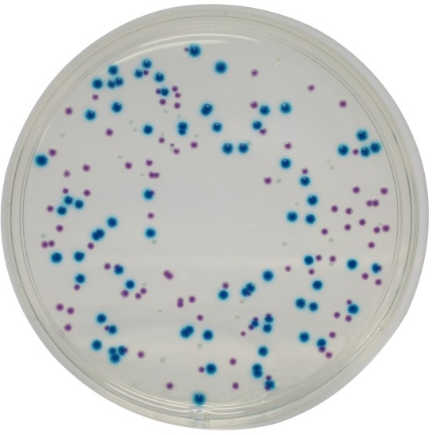

**Pathogenic *Yersinia enterocolitica***: Magenta colonies

**Non-pathogenic strains**: Dark blue colonies or inhibited/no growth