**Chromogenic *Candida* Agar**

|  |  |  |
| --- | --- | --- |
| **Product No.** | **Product Category** | **Specification** |
| CRM016B | Dehydrated Culture Medium | 500g/bottle |

**Intended Use**

For the selective isolation and presumptive identification of *Candida*, particularly *Candida albicans*.

**Principle and Interpretation**

Peptone provides carbon and nitrogen sources.Agar acts as the solidifying agent for the culture medium.Chloramphenicol inhibits the growth of contaminating microorganisms.Chromogenic substrates specifically react with enzymes produced by *Candida*.hydrolyzing the substrate to release a chromogen. *Candida albicans* forms green to blue-green colonies due to its enzymatic activity.

**Formulation**

|  |  |
| --- | --- |
| **Ingredients** | **/liter** |
| Peptone | 10.2g |
| Chromogen Mixture | 22.0g |
| Agar | 15.0g |
| Chloramphenicol | 0.5g |
| pH 6.3±0.2 at 25°C | |

**Preparation**

Weigh out 47.7 g of this medium, add it to 1000 mL of distilled or deionized water, stir, heat, and bring to a boil until completely dissolved. Once cooled to approximately 50℃, pour into sterile Petri dishes under aseptic conditions. Allow the medium to solidify before use.

**Quality Control**

Cultural characteristics observed after incubation at 30-35°C for 48-72 hours

|  |  |  |  |
| --- | --- | --- | --- |
| **Quality control strains** | **Approx. Inoculum(CFU)** | **Recovery** | **Characteristics** |
| Candida albicans ATCC 10231 | 10-100 | PR:0.5-2.0 | Green-blue-green colonies |
| Candida krusei ATCC 34135 | > 104 | - | Purple-red colonies, irregular edges |
| Candida glabrata ATCC 15126 | > 104 | - | Pink periphery with purple-red center |
| Candida tropicalis ATCC 1369 | > 104 | - | Steel-blue colonies |
| Escherichia coli CMCC(B)44102 | > 104 | G≤1 | No growth |

**Storage and Shelf Life**

2-30℃，Keep container tightly closed, avoid direct sunlight.

Use before expiry date on the label.

**Precautions**

1. When weighing the dehydrated medium, please wear masks to avoid causing respiratory system discomfort

2. Keep container tightly closed after using to prevent clumping.

**Waste Disposal**

Microbiological contamination was disposed by autoclaving at 121°C for 30 minutes.

**Revision**

On June 14, 2024

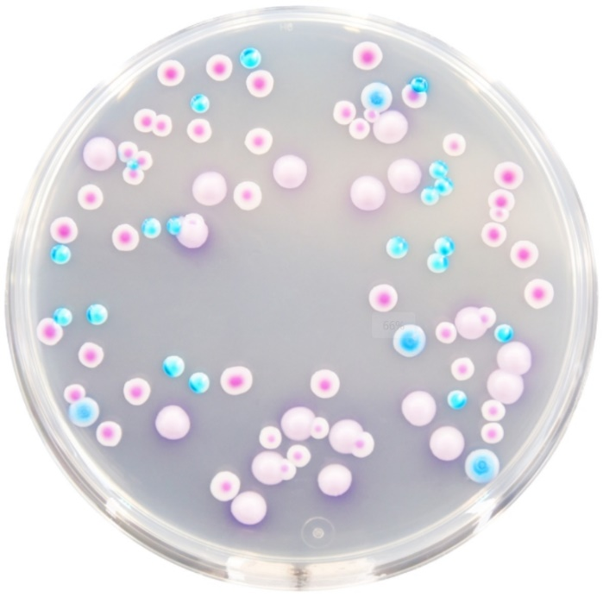

***Candida albicans***: Green-blue-green colonies

**Other microbes**: Magenta colonies, steel-blue colonies, or inhibited/no growth